2020 02 22 NR Daily Log

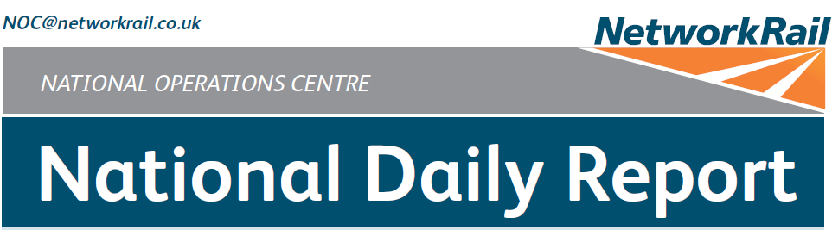



***DATE OF REPORT: NOC MANAGER 0700 – 1900:***

***NOC MANAGER 1900 – 0700:***

***DUTY CONTROLLER 0630 – 1830:***

***DUTY CONTROLLER 1830 – 0630:***

***SUPPORT CONTROLLER 0630 – 1830:***

***SUPPORT CONTROLLER 1830 – 0630:***

***LONDON CONTROLLER 0700 – 1900:***

***LONDON CONTROLLER 1900 – 0700:***

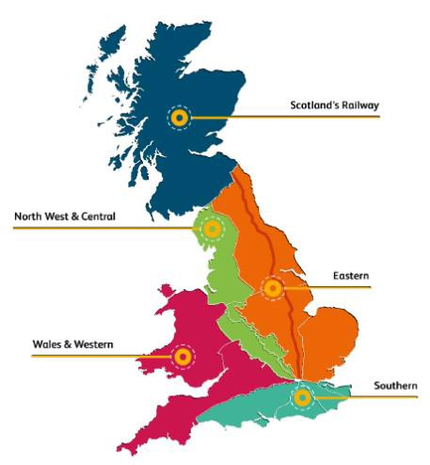

Saturday 22nd February 2020 Mark Elkin

David Burnett Bob Scoot Pete Ure

Graham McIntosh Sophie Crizzle David Newton Martin Dineen

# TABLE OF CONTENTS

1. WRONG SIDE FAILURE REPORTS 3
2. SIGNALS PASSED AT RED (CATEGORY ‘A’) 3
3. DERAILMENTS 3
4. COLLISIONS 3
5. TRAIN OR VEHICLE RUNAWAY 3
6. OPERATIONAL INCIDENTS 3
7. TRAINS WITH STRANDED PASSENGERS 4
8. SIGNIFICANT POSSESSION PROBLEMS 4
9. FATALITIES 4
10. INJURIES/ASSAULTS 4
11. NEAR MISSES 5
12. RAILWAY CRIME 5
13. STATION OVERRUNS 5
14. BROKEN RAILS/TRACK DEFECTS 6
15. POWER FAILURES 7
16. POINTS FAILURES 8
17. SIGNALS/SIGNALLING SYSTEMS FAILURES 8
18. TRACK CIRCUIT & AXLE COUNTER FAILURES 8
19. BRIDGE STRIKES 9
20. ROAD VEHICLE INCURSIONS (NON-LEVEL CROSSINGS) 9
21. TRACTION FAILURES 9
22. WEATHER-RELATED PROBLEMS 10
23. FIRES 12
24. WILD REPORTS & HABD ACTIVATIONS 13
25. GROUP STANDARDS GE/RT8250 & GO/RT3350 14
26. TPWS 14
27. MISCELLANEOUS 15
28. REVIEW TABLE 16
29. REAL TIME PERFORMANCE FIGURES 17

None.

***01 WRONG SIDE FAILURE REPORTS***

***02 SIGNALS PASSED AT RED (CATEGORY ‘A’)***

## Southern (Sussex) – CCIL 2099113 / Fault No. 159533

At 1335, 1E28, Govia Thameslink Railway, 1233 Uckfield – London Bridge, passed T134 signal on the Up Slow line at South Croydon at red by ½ a coach length, being stopped by a TPWS intervention. The driver was challenged and reported a loss of concentration (group 2 cause). After consultation with Govia Thameslink Railway, the driver was judged fit to continue and was met on arrival at East Croydon, where they were relieved for interview and screening.

|  |  |  |  |  |  |  |  |
| --- | --- | --- | --- | --- | --- | --- | --- |
| TRUST 803355 UETD | | | | | | | |
| Cancelled | 1 | Part Cancelled | 2 | Trains Delayed | 14 | Minutes | 61 |

***03 DERAILMENTS***

None.

***04 COLLISIONS***

None.

***05 TRAIN OR VEHICLE RUNAWAY***

None.

***06 OPERATIONAL INCIDENTS***

## Wales and Western (Western) – CCIL 2099079.

At 0949, a Mobile Operations Manager reported that to allow the steam locomotive hauling 1Z83, West Coast Railways, 0709 London Paddington – Worcester Shrub Hill to be watered at Swindon Transfer Yard, a possession of the Transfer Sidings would be arranged to be taken to allow staff to run the water pipes across the tracks. Before the possession could be taken the Mobile Operations Manager became aware that the West Coast Railway staff were already watering the locomotive. All details were passed to West Coast Railways, who will undertake an investigation.

|  |  |  |  |  |  |  |  |
| --- | --- | --- | --- | --- | --- | --- | --- |
| TRUST 802979 TPAA | | | | | | | |
| Cancelled | 0 | Part Cancelled | 0 | Trains Delayed | 1 | Minutes | 24 |

## Southern (Sussex) – CCIL 2099204

At 1522, the driver of 1P40, Govia Thameslink Railway, 1450 Caterham – London Bridge, formed by units 377706 & 377604, consisting of 10 coaches in total, stopped the train at the 4 car marker on the platform at East Croydon and released all the doors. No passengers alighted from the portion not accommodated in the platform. The service was terminated at East Croydon.

|  |  |  |  |  |  |  |  |
| --- | --- | --- | --- | --- | --- | --- | --- |
| TRUST 803530 UETM | | | | | | | |
| Cancelled | 1 | Part Cancelled | 1 | Trains Delayed | 1 | Minutes | 11 |

|  |  |  |  |  |  |
| --- | --- | --- | --- | --- | --- |
| ***Region / Route*** | ***Train*** | ***Since*** | ***Between*** | ***OUTCOME*** | ***CCIL*** |
| Southern (Wessex) | 2V52, Great Western Railway, 0608 Salisbury – Gloucester | 0617-  0712 | Salisbury and Warminster | Shed/marquee blocking line, removed by Pway | 2098965 |
| Southern (Wessex) | 1V02, South Western Railway, 0640 Salisbury – Bristol Temple Meads | 0646-  0716 | Salisbury and Warminster | Shed/marquee blocking line, removed by Pway | 2098965 |
| Scotland | 2M26, ScotRail, 0855 Milngavie – Edinburgh Waverley | 1031 -  1217 | Haymarket Central Junction  – Haymarket East Junction | After the freeing of the trapped trains, the service raised the rear pantograph and was on the move. | 2099100 |
| Scotland | 1R36, ScotRail, 0945 Glasgow Queen Street – Edinburgh Waverley | 1031 -  1145 | Haymarket West Junction – Haymarket central Junction | Following the restoration of OLE traction the services was authorised to proceed. | 2099100 |
| Scotland | 2J70, ScotRail, 0926 Glasgow Queen Street – Edinburgh Waverley | 1031 -  1145 | Edinburgh Park – Haymarket West Junction | Following the restoration of OLE traction the services was authorised to proceed. | 2099100 |
| Scotland | 1R38, ScotRail, 1000 Glasgow Queen Street – Edinburgh Waverley | 1031 -  1145 | Edinburgh Park – Haymarket West Junction | Following the restoration of OLE traction the services was authorised to proceed. | 2099100 |
| Scotland | 2H44, ScotRail, 0854 Helensburgh Central – Edinburgh Waverley | 1031 -  1145 | Edinburgh Park – Haymarket West Junction | Following the restoration of OLE traction the services was authorised to proceed. | 2099100 |
| Scotland | 2M28, ScotRail, 0925 Milngavie – Edinburgh Waverley | 1031 -  1145 | Newbridge Junction – Edinburgh Park | Following the restoration of OLE traction the services was authorised to proceed. | 2099100 |
| Scotland | 1P20, ScotRail, 1011 Stirling - Edinburgh Waverley | 1031 -  1145 | Newbridge Junction – Edinburgh Park | Following the restoration of OLE traction the services was authorised to proceed. | 2099100 |
| Scotland | 1R40, ScotRail, 1015 Glasgow Queen Street – Edinburgh Waverley | 1031 -  1145 | Newbridge Junction – Edinburgh Park | Following the restoration of OLE traction the services was authorised to proceed. | 2099100 |
| Scotland | 2H46, ScotRail, Glasgow Helensburgh Central – Edinburgh Waverley | 1031 -  1145 | Newbridge Junction – Edinburgh Park | Following the restoration of OLE traction the services was authorised to proceed. | 2099100 |
| Scotland | 2J72, ScotRail, 0956 Glasgow Queen Street – Edinburgh Waverley | 1031 -  1145 | Winchburgh Junction – Newbridge Junction | Following the restoration of OLE traction the services was authorised to proceed. | 2099100 |
| Scotland | 1R42, ScotRail, 1030 Glasgow Queen Street – Edinburgh Waverley | 1101 -  1145 | Winchburgh Junction – Newbridge Junction | Following the restoration of OLE traction the services was authorised to proceed. | 2099100 |

***08 SIGNIFICANT POSSESSION PROBLEMS***

None.

***09 FATALITIES***

None.

***10 INJURIES/ASSAULTS***

## Eastern (Anglia) – CCIL 2099306

At 1842, a Network Rail Programme Manager advised of a late reported staff accident. A contractor working for Keltbray at Manor Park became trapped between two RRV vehicles at approximately 1600. An ambulance was called but was not used. The person was taken to hospital to have their injuries assessed. The worksite was closed down by Keltbray management, who were investigating the incident at the close of this Report.

## Scotland CCIL 2099258

At 1948, the Yoker West signaller advised that 2E53, ScotRail, 1846 Airdrie – Balloch was at a stand at Singer station awaiting police attendance as a stabbing was reported to have taken place onboard the train. Paramedics treated the injured party on site (non-life threatening injuries). 2E53 terminated at Singer and ran as ECS to Yoker Depot, where BT Police (ref. 502) and Police Scotland attended at 2028 to examine the train. SOCO arrived at Yoker Depot at 2054.

|  |  |  |  |  |  |  |  |
| --- | --- | --- | --- | --- | --- | --- | --- |
| TRUST 804052 VHAR | | | | | | | |
| Cancelled | 3 | Part Cancelled | 1 | Trains Delayed | 8 | Minutes | 124 |

## North West and Central (North West) - CCIL 2099361

At 2219, a member of P’Way staff reported that they were removing spikes from the track with an extractor, which sprung up and struck them and broke their nose. The person was conveyed to hospital for treatment.

***11 NEAR MISSES***

## Eastern (East Coast) – CCIL 2099184

At 1349, the driver of 2D36, Northern, 1226 Bishop Auckland - Saltburn, reported a near miss at Saltburn Riding School (UWC) level crossing with two persons on horseback. The riders crossed as the train approached and the driver applied the emergency brake. The driver was fit to continue. The BT Police were advised by email. The signaller confirmed that they had not received any requests to use the crossing. A Mobile Operations Manager attended and confirmed both phones were working correctly.

***12 RAILWAY CRIME***

None.

***13 STATION OVERRUNS***

## North West and Central (C) – CCIL 2099024

At 0733, 1G09, Chiltern, 0700 London Marylebone – Birmingham Snow Hill, formed by units 168110 & 168106, comprising seven coaches in all, overran Princes Risborough station by an unknown distance. The driver was not authorised to return to the station and was instructed to continue to Haddenham & Thame Parkway. The driver stated that the overrun was due to mis-judging the braking distance for a seven car unit. The driver was fit to continue to Birmingham Moor Street where they were relieved.

|  |  |  |  |  |  |  |  |
| --- | --- | --- | --- | --- | --- | --- | --- |
| TRUST 802625 THOC | | | | | | | |
| Cancelled | 2 | Part Cancelled | 0 | Trains Delayed | 1 | Minutes | 2 |

## Southern (Kent) – CCIL 2099145

At 1212, 2R28, Southeastern, 1031 London Victoria – Dover Priory, formed by units 375907 & 375925, comprising eight coaches, overran Sandling station by ½ a coach length, with one set of doors affected not released. The driver stated that the overrun was due to poor adhesion. The driver was fit to continue. The next service reported no issues in stopping at the station. A Mobile Operations Manager was sent to site with drivers of subsequent services advised. At 1300 the Mobile Operations Manager reported that the rails on both lines were clean.

|  |  |  |  |  |  |  |  |
| --- | --- | --- | --- | --- | --- | --- | --- |
| TRUST 803215 MHUZ | | | | | | | |
| Cancelled | 0 | Part Cancelled | 0 | Trains Delayed | 2 | Minutes | 12 |

## Eastern (Anglia) – CCIL 2098921 / Fault No. 305813

At 0256, P’Way staff reported that whilst carrying out a crossing inspection at Stowmarket station, they had discovered a rail defect on the Down Main line that would require an immediate 5mph ESR. Staff were sent from site to collect the ESR boards. Staff on site requested a Line Blockage of the Up Main line in order to provide protection to replace the rail and increase the ESR to 50mph, but this was not possible due to single line working in use due to repairs ongoing to another rail defect at Stowmarket. The ESR boards were erected by 0508. Significant delay was incurred by freight services through the area.

|  |  |  |  |  |  |  |  |
| --- | --- | --- | --- | --- | --- | --- | --- |
| TRUST 802188 IQHM | | | | | | | |
| Cancelled | 1 | Part Cancelled | 5 | Trains Delayed | 34 | Minutes | 1327 |

|  |  |  |  |  |  |  |  |
| --- | --- | --- | --- | --- | --- | --- | --- |
| TRUST 802281 IQHM | | | | | | | |
| Cancelled | 0 | Part Cancelled | 0 | Trains Delayed | 11 | Minutes | 72 |

## Wales and Western (Western) – CCIL 2099066 / Fault No. 461293

At 0925, the Single line between Shelwick Junction and Ledbury was blocked after the driver of 1V22, West Midlands Trains, 0750 Birmingham New Street – Hereford reported a distorted rail. A Mobile Operations Manager and P’Way staff were sent to site. Services were terminated at Great Malvern. At 1005, the Mobile Operations Manager reported a visible kink in the rail at 144m18ch at the end of recent tamper work. Remedial work was undertaken by P’Way staff, with the line reopened at 1331 and a 20 mph ESR imposed. Further work was undertaken between trains with line speed restored at 1732.

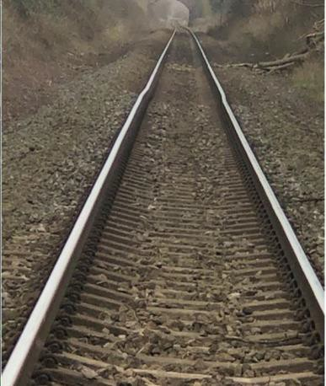

|  |  |  |  |  |  |  |  |
| --- | --- | --- | --- | --- | --- | --- | --- |
| TRUST 802894 IQWS | | | | | | | |
| Cancelled | 6 | Part Cancelled | 8 | Trains Delayed | 4 | Minutes | 18 |

## Wales and Western (Western) – CCIL 2098964 / Fault No. 461303

At 1321 P’Way staff reported that they had discovered a cracked weld on the Up Kemble line between Kemble and Swindon Junction. The line was blocked pending inspection by a Welding Supervisor. At 1351 authority was given for the line to be reopened with a 20mph ESR imposed after a Watchman was in place. At 1449 the Maintenance Engineer reported that the defect was to be classed as a Cat 1A defect requiring immediate clamping with repairs to be completed within 36/48 hours. A Mobile Operations Manager attended to act as the Rail Defect Nominee but was only able to open the line with a 5mph ESR imposed. Clamps were installed by 1632, allowing the ESR to be eased to 20mph. Services were cautioned until the warning boards were in place at 1742. Full rectification work is planned to take place overnight tonight (Sunday) within a booked possession.

|  |  |  |  |  |  |  |  |
| --- | --- | --- | --- | --- | --- | --- | --- |
| TRUST 803329 IQDB | | | | | | | |
| Cancelled | 1 | Part Cancelled | 4 | Trains Delayed | 15 | Minutes | 262 |

## North West and Central (NW) – CCIL 2098933 / Fault No. 883082

At 0614, the driver of 1F27, West Midlands Trains, 0548 Crewe Liverpool Lime Street, reported witnessing a flash from the OLE as the train approached DN103 signal on the Down Ditton line at Runcorn bridge. Crewe ECO advised that section PW6 had tripped at 0608 and reset at 0612. This was in the same area as the previous OLE dewirement on 20/02/20. A following service examined the line and reported that the return conductor was down and not safe to pass on the Down Ditton line. A block to services was placed between Crewe and Liverpool. The examining service 1B00, Transport for Wales, 0604 Chester – Liverpool Lime Street, was set back to Runcorn where it terminated and formed the return service to Chester. Up line services were unaffected and diesel services were authorised to Runcorn where they terminated. Avanti West Coast services were diverted via the Chat Moss lines or terminated at Warrington Bank Quay. A Mobile Operations Manager and OHL staff were mobilised to site and an isolation of the affected section was granted at 0732 by Crewe ECO once all electric traction services were clear of the limits. At 0910, following the passage of 1A17, Avanti West Coast, Liverpool Lime Streel – London Euston, a Line Blockage of the Up and Down Ditton lines was granted to undertake the rectification work. Initial estimates for the completion of work slipped when staff on site experienced equipment failure, but this was overcome and the Line Blockage and isolation were handed back at 1105, allowing normal signalling to resume.

|  |  |  |  |  |  |  |  |
| --- | --- | --- | --- | --- | --- | --- | --- |
| TRUST 802491 IQFJ | | | | | | | |
| Cancelled | 1 | Part Cancelled | 27 | Trains Delayed | 42 | Minutes | 798 |

## Scotland – CCIL 2099100 / Fault No. 350283

At 1031, Cathcart ECO reported that OLE sections PC1, 2, 3 & 4 had tripped between Haymarket Central and East Junctions. Sections PC1, 2 & 3 reset at 1033, with two services in section. The drivers of 2M26, ScotRail, 0855 Milngavie – Edinburgh Waverley and 1P18, ScotRail, 0936 Stirling – Edinburgh Waverley were requested to lower their pantographs. Section PC4 was re-energised once the pantographs were lowered. The pantograph of 1P18 was raised and the service was authorised forward to Edinburgh Waverley 33 minutes late. Multiple services were trapped in rear (see section **07** of this report). A block to services from Glasgow Queen Street was put in place. When the driver of 2M26 attempted to raise their pantograph, section PC4 again tripped. The driver reported a loud bang when the pantograph was raised. The driver of 1R36, ScotRail, 0945 Glasgow Queen Street – Edinburgh Waverley, reported having issues resetting the train prior to raising their pantograph. These were overcome and the service was on the move at 1145. This cleared a route for other trapped services to be signalled via Haymarket Central Junction to Edinburgh Waverley. At 1217, the rear pantograph was raised on 2M26 without incident, allowing the service to proceed to Edinburgh Waverley. The unit was taken out of service and ran ECS to Yoker for maintenance attention. OHL staff reported no issues found during their examination of the OHL infrastructure.

|  |  |  |  |  |  |  |  |
| --- | --- | --- | --- | --- | --- | --- | --- |
| TRUST 803092 MHAS | | | | | | | |
| Cancelled | 54 | Part Cancelled | 13 | Trains Delayed | 55 | Minutes | 1452 |

|  |  |  |  |  |  |  |  |
| --- | --- | --- | --- | --- | --- | --- | --- |
| TRUST 802992 CQL8 | | | | | | | |
| Cancelled | 10 | Part Cancelled | 9 | Trains Delayed | 64 | Minutes | 472 |

## Southern (Sussex) – CCIL 2099146 / Fault No. 159531

At 1212, detection was momentarily lost on No.1849 points at Brighton, causing T446 signal on platform 7 at Brighton to revert to danger. The signaller maintained the points in the Normal position but was unable set a route, preventing services to access the Down Main lines or to be routed towards Lewes. A Mobile Operations Manager and S&T staff were sent to site, with alternative routes being used. Initial investigations were undertaken by S&T staff with the points losing detection when moved to Reverse. The points were secured in the Normal position pending further investigations. A gap in the service was created to allow S&T staff 20 minutes access at 1620 to undertake further testing, with the points restored at 1640 after attention to the points motor.

|  |  |  |  |  |  |  |  |
| --- | --- | --- | --- | --- | --- | --- | --- |
| TRUST 803199 IQBG | | | | | | | |
| Cancelled | 28 | Part Cancelled | 22 | Trains Delayed | 66 | Minutes | 1058 |

## Eastern (East Coast) – CCIL 2099168 / Fault No. 788712

At 1313, the Shift Signalling Manager at Doncaster PSB reported No.2258 points had failed with no Normal or Reverse detection at Retford North Junction on the Down Main line to Up Main line crossover. 1N83, London North Eastern Railway, 1106 London King’s Cross - York was trapped in section. Other services were diverted via the Down Slow line. S&T staff and a Mobile Operations Manager were mobilised to site. At 1336, it was confirmed that the points had been secured in the Normal position with detection, allowing services to resume running, but that there was significant damage to the points gears and motor. P’Way and S&T staff were requested to attend, as voiding was apparent below the sleepers and was the likely cause of the broken motor and gearbox. Repairs were carried out in between trains and commenced at 1459. Further parts were sourced for renewals overnight.

|  |  |  |  |  |  |  |  |
| --- | --- | --- | --- | --- | --- | --- | --- |
| TRUST 803306 IQIJ | | | | | | | |
| Cancelled | 0 | Part Cancelled | 2 | Trains Delayed | 55 | Minutes | 566 |

***17 SIGNALS/SIGNALLING SYSTEMS FAILURES***

## Eastern (East Coast) – CCIL 2099163 / Fault No. 788707

At 1229, the signaller at Tweedmouth reported that Belford CCTV level crossing had failed between Belford Crossovers and Crag Mill Loop, holding one signal in each direction at red. Services were cautioned from T109 signal on the Down Main line and T112 signal on the Up Main line. S&T staff and a Mobile Operations Manager were mobilised to site. Staff were confirmed on site at 1340 and at 1425 they signed the crossing back in use, allowing normal signalling to resume. S&T staff advised that the failure was due to a microswitch which was associated with the defective boom. A replacement was sourced and late turn staff attended at 1615. Repairs were ongoing at the close of this Report.

|  |  |  |  |  |  |  |  |
| --- | --- | --- | --- | --- | --- | --- | --- |
| TRUST 803243 IQIF | | | | | | | |
| Cancelled | 1 | Part Cancelled | 4 | Trains Delayed | 184 | Minutes | 2320 |

## North West and Central (North West) - CCIL 2099296 / Fault No. 883137

At 1759, the driver of 1S76, Avanti West Coast, 1430 London Euston – Glasgow Central, reported that CE492 signal on the Down Main line between Carlisle and Gretna Green, had reverted from green to red as the train approached. The driver was unable to stop and passed the signal at red by one train length. There was no apparent reason for the reversion with investigations ongoing at the close of this Report. The driver was fit to continue once the circumstance had been explained.

***18 TRACK CIRCUIT & AXLE COUNTER FAILURES***

None.

***19 BRIDGE STRIKES***

|  |  |  |  |  |  |  |  |
| --- | --- | --- | --- | --- | --- | --- | --- |
| ***Region / Route*** | ***Time*** | ***Location*** | ***Bridge No.*** | ***Dispensation*** | ***NWR*** | ***CCIL*** | ***TRUST*** |
| Eastern (East Coast) | 0841 | Little Ponton | ECM1/236 | G | 0841 | 2099057 | No delay recorded. |

***20 ROAD VEHICLE INCURSIONS (NON-LEVEL CROSSINGS)***

None.

***21 TRACTION FAILURES***

## North West and Central (WCMLS) - CCIL 2098926

At 0322, the driver of 4O22, Freightliner, 0123 Trafford Park Freightliner Terminal – Southampton Maritime, hauled by 66525, declared the locomotive a failure at Penkridge and would require assistance. 4M73, Freightliner, 2141 Felixstowe North Freightliner Terminal – Ditton was identified as the rescue locomotive to take 4O22 back to Basford Hall. A Mobile Operations Manager was dispatched to site to collect the driver from the failed train and convey them to Stafford to assist with the assisting locomotive. Services routed via Wolverhampton were diverted via WCML and Transport for Wales services via Shrewsbury. The Mobile Operations Manager and driver arrived at Stafford at 0459 and reported that the driver on 4M73 was out of hours and that the failed train driver would complete the move with the locomotive. A locomotive was dispatched from Basford Hall at 0516 to attach to 4M73 and take the train forward to destination. At 0609 it was advised that the assisting locomotive was attached to 4O22 and at 0619 the combined train was on the move allowing normal signalling to resume. The locomotive from Basford Hall was attached to 4M73 and on the move at 0707.

|  |  |  |  |  |  |  |  |
| --- | --- | --- | --- | --- | --- | --- | --- |
| TRUST 802256 MDBF | | | | | | | |
| Cancelled | 0 | Part Cancelled | 2 | Trains Delayed | 18 | Minutes | 415 |

## North West and Central (C) – CCIL 2099116

At 1110, 2Y06, West Midlands Trains, Crewe – London Euston formed by unit 350119, came to a stand at Marston Green station with a red transformer fault light. The driver sought advice from maintenance control. One service was trapped in section and this was authorised to set back to Lea Hall. The driver of 2Y06 declared the train a failure at 1132. Assistance was sought from 2H59, West Midlands Trains, London Euston – Rugeley Trent Valley that was terminated at Birmingham International. At 1202 the assisting unit was authorised into section and the combined train was on the move at 1249, allowing normal signalling to resume.

|  |  |  |  |  |  |  |  |
| --- | --- | --- | --- | --- | --- | --- | --- |
| TRUST 803102 MEJI | | | | | | | |
| Cancelled | 6 | Part Cancelled | 40 | Trains Delayed | 188 | Minutes | 2004 |

## Eastern (North & East) – CCIL 2099188

At 1416, 1P72, TransPennine Express, 1207 Redcar Central – Manchester Airport, formed by unit 185118, came to a stand at Heaton Lodge Junction with a loss of power. One service was trapped in rear. 1P26, TransPennine Express, 1245 Newcastle Central – Manchester Airport, was identified to assist from the front. A Mobile Operations Manager was dispatched. 1P26 was reported at Heaton Lodge Junction at 1453 and was authorised to set back to 1P72, once 1P26 was clear of the points. Services were diverted via platform 3 at Mirfield. The trapped service 1F66, TransPennine Express, 1234 Scarborough – Liverpool Lime Street, was set back and diverted via Mirfield platform 3. Following initial problems with releasing the brakes, the combined train was on the move at 1546, allowing normal signalling to resume.

|  |  |  |  |  |  |  |  |
| --- | --- | --- | --- | --- | --- | --- | --- |
| TRUST 803431 MEAZ | | | | | | | |
| Cancelled | 1 | Part Cancelled | 6 | Trains Delayed | 56 | Minutes | 780 |

***22 WEATHER-RELATED PROBLEMS***

Below is a table capturing the most significant weather related issues across the Network:

|  |  |  |  |  |  |  |  |
| --- | --- | --- | --- | --- | --- | --- | --- |
| ***REGION*** | ***ROUTE*** | ***LOCATION*** | ***CAUSE*** | ***ROUTE BLOCKED*** | ***TIME*** | ***NO. OF TRAPPED TRAINS*** | ***CCIL*** |
| Eastern | East Coast | Welwyn South Junction – Arlesey | Wind Speed  80mph ESR for Electric Traction |  | 0823 -  1041 | N/A | 2099050 |
| East Coast | Huntingdon - Tallington | Wind Speed  80mph ESR for Electric Traction |  | 0933 -  1154 | N/A | 2099050 |
| East Coast | Belford - Scottish Boarder | Wind Speed  80mph ESR for Electric Traction |  | 0950 | N/A | 2099087 |
| East Coast | Temple Hirst to York | Wind Speed  80mph ESR for Electric Traction |  | 1200 | N/A | 2099143 |
| East Coast | Tallington - Peascliffe Crossovers | Wind Speed  80mph ESR for Electric Traction |  | 1530 | N/A | Not logged |
| Southern | Sussex | Hove Tunnel | Landslip | Down West Branch line | 0517 –  close of service | 0 | 2098953 |
| Wessex | Wilton Jn | Shed/marquee on Up line | Salisbury - Warminster | 0540 -  0712 | 2 | 2098965 |
| Putney | Precarious tree | Putney Up Slow blocked | 1344 –  1543 | 0 | 2099177 |
| Wales & Western | Wales | Black Bridge | Rail over river bridge, water above closure mark | Talerddig - Machynlleth | 0044 (Sat)  - 1748 | 0 | 2098895 |
| Knighton | Flowing flood water | Knighton – Nucklas | 0626 -  0920 | 0 | 2098992 |

## Scotland – CCIL 2096858 / Fault No. 349992

With reference to the item in this section of yesterday’s Report concerning flooding at Mill O’Kier viaduct. The Watchman reported at 1000 that the water level was still above the red marker, the lines remained closed throughout the day with the structures engineer expected on site Sunday morning. An emergency timetable has been implemented for Sunday.

|  |  |  |  |  |  |  |  |
| --- | --- | --- | --- | --- | --- | --- | --- |
| TRUST 801090 XQLF | | | | | | | |
| Cancelled | 49 | Part Cancelled | 53 | Trains Delayed | 63 | Minutes | 1016 |

## Scotland – CCIL 2091381 / Fault No. 349312

With reference to the item in this section of yesterday’s Report concerning flooding in at Knightswood Tunnel. At 0353 the Track Section Manager reported that the water levels had receded significantly, allowing normal signalling to resume.

|  |  |  |  |  |  |  |  |
| --- | --- | --- | --- | --- | --- | --- | --- |
| TRUST 800463 XQLY | | | | | | | |
| Cancelled | 7 | Part Cancelled | 39 | Trains Delayed | 189 | Minutes | 1291 |

|  |  |  |  |  |  |  |  |
| --- | --- | --- | --- | --- | --- | --- | --- |
| TRUST 764181 XQLY | | | | | | | |
| Cancelled | 0 | Part Cancelled | 0 | Trains Delayed | 10 | Minutes | 39 |

## Scotland – CCIL 2098830 / Fault No. 350235

With reference to the item in this section of yesterday’s Report concerning high water levels at Bowling. P’Way staff were on site at 0310 and reported that the water levels had receded to allow trains to run at 5mph. By 0440 it was reported that the water level had receded sufficiently to allow normal signalling to resume, with the first train on each line to be cautioned through due to visible debris. At 0641 normal signalling was resumed after nothing was reported untoward.

|  |  |  |  |  |  |  |  |
| --- | --- | --- | --- | --- | --- | --- | --- |
| TRUST 801634 XQLY | | | | | | | |
| Cancelled | 19 | Part Cancelled | 9 | Trains Delayed | 6 | Minutes | 34 |

## Scotland – CCIL 2098693 / Fault No. 350218

At 1856 (Fri), the watchman at Dalguise Viaduct reported that the water level had passed the yellow marker. The water level continued to rise through the evening until 2309 when the red mark was breached, resulting in a block to traffic over the Single line. No services were booked through the section overnight and at 0400 (Sat) the watchman reported that the water level was still above the red marker. This remained the case until 0926 when the water level fell below the mark. Staff were mobilised to undertake examinations and checks in readiness for the lines to reopen. This was completed at 1358 and the structures examiner authorised the Single line to be opened with a 20mph speed in place until the water level dropped below the yellow marker. Linespeed was reinstated at 1911.

|  |  |  |  |  |  |  |  |
| --- | --- | --- | --- | --- | --- | --- | --- |
| TRUST 803523 XQLV | | | | | | | |
| Cancelled | 1 | Part Cancelled | 0 | Trains Delayed | 10 | Minutes | 485 |

## Wales and Western (Wales) – CCIL 2098895

Following a flood warning at 0044 (Saturday), P’Way staff blocked the line at Black Bridge, between Talerddig and Machynlleth, as they could not see the flood markers. Transport for Wales advised at 0200 (Saturday) that they had cancelled all services up to 1300. P’Way reported at 0416 that the water level had risen by a further 12 inches. A further inspection was made at 1300 but, although the water levels had fallen below the closure mark, there was low confidence that levels wouldn’t rise again, therefore the route remained blocked pending a further inspection at 1700. Line speed was restored at 1748 after inspections had been completed.

|  |  |  |  |  |  |  |  |
| --- | --- | --- | --- | --- | --- | --- | --- |
| TRUST 802336 XQWS | | | | | | | |
| Cancelled | 10 | Part Cancelled | 2 | Trains Delayed | 3 | Minutes | 15 |

## Southern (Sussex) – CCIL 2098953 / Fault No. 159527

At 0517, the driver of 1N96, Govia Thameslink Railway, 0514 Brighton – Southampton Central, reported a land slip on the Down West Branch line on approach to Hove Tunnel. The driver was able to remove the debris from under the train and continue, reporting that the line was not passable, but the Up West Branch line was not affected. A Mobile Operations Manager and P’Way staff were sent to site. At 0613, the Mobile Operations Manager confirmed that the Down line was required to remain blocked due to the landslip. Service revisions were implemented with affected operators and ticket acceptance in place with local bus routes. An Earthworks Engineer was sent to site, arriving at 0844. At 0956 it was reported from site that the line must remain blocked until the unstable overhang of the embankment has been brought down and removed from site. Approximately three hours work was required for the stabilisation work, but difficulties were experienced in resourcing the required staff. The work was deferred until after the close of service.

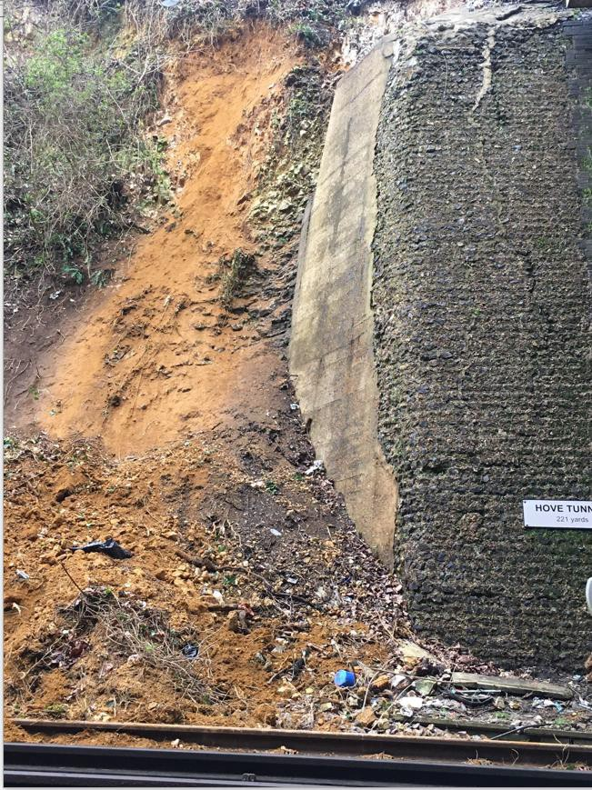

|  |  |  |  |  |  |  |  |
| --- | --- | --- | --- | --- | --- | --- | --- |
| TRUST 802420 IQBG | | | | | | | |
| Cancelled | 185 | Part Cancelled | 16 | Trains Delayed | 88 | Minutes | 819 |

## North West and Central (NW) – CCIL 2098959 / Fault No. 883076

At 0529, the Shift Signalling Manager at Preston PSB reported that track circuit no. 688 on the Up L&Y line at Summit Tunnel had failed holding PN328 signal at red. S&T staff were mobilised to site but were later stood down. The driver of 1K05, TransPennine Express, 0515 Manchester Piccadilly – Hull reported standing water at sleeper level within the tunnel on both the Down & Up L&Y lines. Services continued to be authorised passed PN328 signal at red throughout the day and at 1722 the driver of 1D72, Northern, 1542 Leeds – Chester, reported the water level on the Down L&Y line was below the railhead. Investigations were ongoing at the close of this Report.

|  |  |  |  |  |  |  |  |
| --- | --- | --- | --- | --- | --- | --- | --- |
| TRUST 802376 IQFP | | | | | | | |
| Cancelled | 0 | Part Cancelled | 0 | Trains Delayed | 169 | Minutes | 1267 |

***23 FIRES***

None.

## Disconnected Hot Axle Box Detectors:

|  |  |  |  |  |  |  |  |  |  |
| --- | --- | --- | --- | --- | --- | --- | --- | --- | --- |
| *Region / Route* | *Location* | *Line* | *Date Disconnected* | *Reason* | *TOC’s/ FOC’s*  *advised* | *Planned Restoration Date* | *Date Restored* | *Function* | *Fault Number* |
| Eastern (Anglia) | Brentwood | Down Electric | 10/03/16 | Offline | Y | Awaiting update |  | IM | 234632 |
| Eastern (Anglia) | Brentwood | Down Main | 10/03/16 | Offline | Y | Awaiting update |  | IM | 234632 |
| Eastern (Anglia) | Margaretting | Up Main | 19/09/19 |  | Y | Awaiting update |  | IM | 298498 |
| Eastern (EM) | Branston | Up Tamworth | 18/02/20 | Defective | Y | Awaiting update |  | IM | 154332 |
| Eastern (EM) | Chiltern Green | Down Slow | 11/07/19 | Defective | Y | Awaiting update |  |  | 148559 |
| Eastern (EM) | Napsbury | Up Fast | 11/07/19 | Defective | Y | Awaiting update |  |  | 148559 |
| Eastern (EM) | Langley Mill | Up & Down Erewash Slow | 13/02/20 | SK4 fault | Y | Awaiting update | 18/02/20 | IM | 1564199 |
| Eastern (LNE) | Barkston | Up Main | 01/04/19 | Removed for P’Way work | Y | Awaiting update |  |  |  |
| NW & Central (NW) | Bolton-le- Sands | Up Main | 25/08/19 | Integrity Fault | Y | Awaiting update |  |  | 863361 |
| NW & Central (NW) | Hest Bank | Up Main | 25/08/19 | Integrity Fault | Y | Awaiting update |  |  | 863360 |
| NW & Central (NW) | Low Mill | Down Main | 26/11/14 | Awaiting replacement | Y | Awaiting update |  | IP | 671852 |
| NW & Central (NW) | Sutton Weaver | Down Main |  |  | Y | Awaiting update |  |  |  |
| NW & Central (WCMLS) | Bradnocks Marsh (Coventry) | Up Main | 29/12/19 | Integrity | Y | Awaiting Update |  |  | 872142 |
| NW & Central (WCMLS) | Castlethorpe | Up Fast | 27/11/18 | Error code 6.0 | Y | Awaiting Update |  | IM | 832410 |
| NW & Central (WCMLS) | Harecastle | Up Main | 01/04/19 | Rail incorrectly drilled | Y | Awaiting Update |  |  |  |
| NW & Central (WCMLS) | Penkridge | Up Penkridge | 04/11/19 | Integrity | Y | Awaiting Update |  |  | 870982 |
| Wales & Western (Wales) | Dainton | Down Main | 17/11/19 | Defective PC | Y | Awaiting Update |  | IM | 453850 |
| Wales & Western (Wales) | Pembrey | Up | 17/02/20 | Constantly alarming | Y | Awaiting Update |  | IM | 460854 |
| Wales & Western (Western) | Cogload | Down Main | 25/01/20 |  | Y |  |  |  | 458740 |
| Wales & Western (Western) | Treverrin | Down Main | 01/07/19 |  | Y | Awaiting Update |  |  | 443474 |
| Wales & Western (Western) | Twerton | Down Main | 19/11/19 |  | Y | Awaiting Update |  |  | 454030 |
| Wales & Western (Western) | Warminster | Up Salisbury | 22/01/20 | Defective | Y | Awaiting Update |  |  | 458111 |

## Disconnected Wheel Impact Load Detectors:

|  |  |  |  |  |  |  |  |  |  |
| --- | --- | --- | --- | --- | --- | --- | --- | --- | --- |
| *Region / Route* | *Location* | *Line* | *Date Disconnected* | *Reason* | *TOC’s/ FOC’s*  *advised* | *Planned Restorati on Date* | *Date Restored* | *Function* | *Fault Number* |
| Eastern (EC) | Sessay | Up Slow | 18/06/2019 | Calibration |  |  |  | IM |  |
| North West & Central (NW) | Heaton Chapel | Up Slow | 30/07/2019 | Calibration |  |  |  | IM |  |
| Southern (Kent) | Sevington | Down Main | 25/04/2018 | PC Failure |  |  |  | IM |  |
| Southern (Kent) | Sevington | Up Main | 09/08/2018 | PC Failure |  |  |  | IM |  |
| Southern (Kent) | Swanley | Up Slow | 02/04/2019 | Calibration |  |  |  | IM |  |
| Scotland | Howwood | Up | 20/01/2019 | HOBC |  |  |  | IM |  |
| Wales & Western (Western) | Urchfont | Up | 11/04/2019 | PC Failure |  |  |  | IM |  |
| Wales & Western (Western) | Urchfont | Down | 11/04/2019 | PC Failure |  |  |  | IM |  |

***25 GROUP STANDARDS GE/RT8250 & GO/RT3350***

None.

***26 TPWS***

|  |  |  |  |  |  |  |  |  |
| --- | --- | --- | --- | --- | --- | --- | --- | --- |
| ***Region*** | ***Route*** | ***Train*** | ***Signal/PSR/ Buffer Stop*** | ***Line/Platform*** | ***Location*** | ***Speed (reported)*** | ***Speed (set)*** | ***CCIL*** |
| Southern | Wessex | 2H37, South Western Railway, 1412 London Waterloo – Shepperton | 15 PSR | Down | Shepperton | 40 mph | 55 mph | 2099205 |
| North West and Central | NW | 1N54, Northern, 0844 Manchester Airport – Blackpool North | 40 PSR | Down Airport | Heald Green West Junction | 55 mph | 55 mph | 2099062 |
| Eastern | EM | 9O77, Govia Thameslink Railway, 2122 St. Albans City  - Sutton | WH254  signal | Up Slow | Radlett | Not reported | 46 mph | 2099353 |

## Wales & Western (Western) - CCIL 2099065 / Fault No. 461294

At 0904, the driver of 1A10, Great Western Railway, 0657 Taunton – London Paddington, reported that the train had come to a stand on the Up Main line at Cholsey with multiple alarms activated on unit 800321. The driver checked under the train and discovered a severed AWS cable which had thrown up ballast and damaged windows on the train, with the train having possibly struck something. 1L64, Great Western Railway, 0649 Cheltenham Spa – London Paddington, had also sustained window damage. Staff were sent to the area to examine the line with services diverted to the Up Relief line where possible. Pieces of metal were found on the track in the vicinity of the AWS magnet for T824. The AWS magnet was tested and found to be in order with the pieces of metal found to be from a Location Cabinet Door. Following inspection and removal metal pieces, the Up Main line was restored to normal use at 1218.

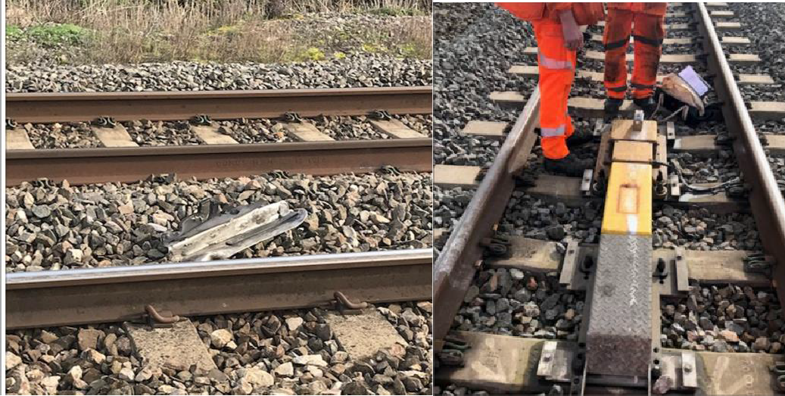

|  |  |  |  |  |  |  |  |
| --- | --- | --- | --- | --- | --- | --- | --- |
| TRUST 802824 XQDZ | | | | | | | |
| Cancelled | 9 | Part Cancelled | 1 | Trains Delayed | 88 | Minutes | 876 |

## Scotland - CCIL 2099300

At 1701, Scottish Gas Networks (SGN) reported that a local resident had hit a gas pipe near the railway between Singer and Dalmuir. An SGN engineer was on site at 1840 and advised that a high volume gas leak had been identified, with emergency repairs required as soon as possible and a 10 metre exclusion zone, which incorporated the railway, to be put in place. A Mobile Operations Manager was on site at 1845 and appointed RIO. Trains were diverted away from the area via Yoker. OHL staff were on site at 1952 to switch the power off however, this was delayed due to an ongoing incident at Singer, see section **10**. At 2119, the RIO confirmed that there were no restrictions to running diesel traction. A Line Blockage was taken from 2125 to 2206 for OHL staff to complete the isolation. A BTET was imposed and the RIO stood down at 2216. Repairs were ongoing at the close of this Report.

|  |  |  |  |  |  |  |  |
| --- | --- | --- | --- | --- | --- | --- | --- |
| TRUST 804314 XQLY | | | | | | | |
| Cancelled | 0 | Part Cancelled | 2 | Trains Delayed | 1 | Minutes | 4 |

|  |  |  |
| --- | --- | --- |
| ***INCIDENT*** | ***TODAY’S TOTAL*** | ***DAYS SINCE LAST INCIDENT*** |
| **PASSENGER ACCIDENTAL FATALITIES** | **0** | **444** |
| **RAILWAY WORKFORCE FATALITIES** | **0** | **70** |
| **SIGNALS PASSED AT RED (CATEGORY ‘A’)** | **1** | **0** |
| **SIGNALS PASSED AT DANGER (ERROR/TECHNICAL SIGNAL REVERSION)** | **1** | **0** |
| **DERAILMENTS** | **0** | **1** |
| **TRAIN COLLISIONS** | **0** | **9** |
| **TRAINS STRIKING ROAD VEHICLES** | **0** | **25** |
| **ENVIRONMENTAL INCIDENTS** | **0** | **11** |

